This document outlines the various LANDIS-II scenarios being run for the NWCSC aspen project. It includes study extents, descriptions of extensions being used, and specific goals/questions associated with each study extent/scenario

**Reynolds Creek Experimental Watershed (RCEW) scenarios**

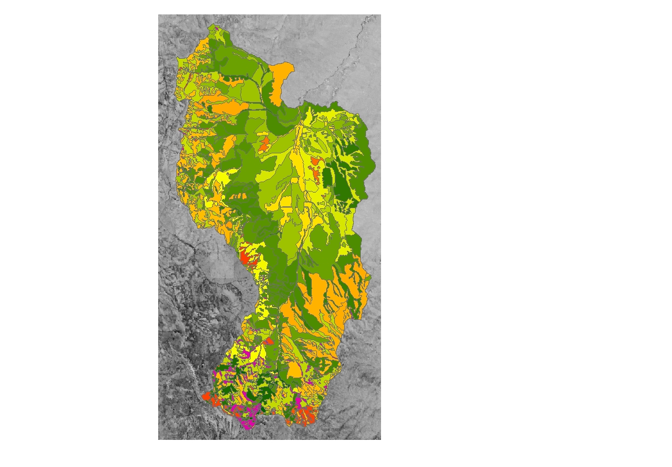*Goals* Analyze relationships between aspen distribution, snow pack, and climate change at a fine spatial scale.

Figure : Reynolds Creek Experimental Watershed vegetation classes. The areas in pink in the south have significant aspen components, while the dark green in the south have mixed Douglas fir communities

*Study Extent*: Forested sections of Reynolds Creek Experimental Watershed, namely Tollgate and Dobson creek sub-watersheds.

*Extensions*: Biomass Succession, no disturbance extensions

*Cell size:* 30 x 30m

*Simulation duration*: 90 years

*Narrative*: The Reynolds Creek Experimental Watershed (RCEW) is a highly instrumented and studied ~24k ha watershed in southwestern Idaho. The watershed transitions from mixed sagebrush communities in the lower elevation north into mixed Douglas Fir/sagebrush and finally dispersed aspen communities in the higher elevation south. Aspen communities there are reliant on concentrated snow banks to sustain soil moisture into the spring and summer.

Our goal is to understand the emergent spatial patterns of aspen that result from changing climate and fine-scale snow hydrology. We will integrate estimated aspen/snow bank relationships as accurately as possible within the LANDIS modeling environment to assess aspen stability under various climate scenarios. Additionally, the upper reaches of the RCEW have relatively low tree diversity, so the regulation of regeneration and recruitment can be studied within a relatively small number of competing species (Douglas fir, trembling aspen, big sagebrush, juniper).

Because the study extent is relatively small (the forested portion of the watershed is a small subset of the entire area), we can run LANDIS-II at a fine spatial resolution (10x10m cells). This fine scale resolution will allow us to answer questions about the role of hydrology in the long term dynamics of aspen communities. Additionally, because of this small scale, no disturbances or relatively simplified disturbance regimes will be modeled in these scenarios.

This extent will be the first modeled, as many of the parameters derived for this scenario can be transferred to the larger landscape (see below). An additional advantage of starting with this smaller extent is the ability to more directly integrate with other parts of the CSC project. For example, Biome-BGC will be used to derive max ANPP values for all tree species. Given that Ben and Katy’s study sites fall within the RCEW, this will allow us to initially avoid approximation or interpolation of ANPP values to areas they have not studied. Tim’s snowbank work can also be more directly integrated for similar reasons. The smaller cell size will also allow us to capture more fine scale snow dynamics that the larger landscape will not be able to represent.

*Hypotheses:*

1. Fine scale topographic variability, including those features that facilitate precipitation redistribution and accumulation, provide microrefugia for dispersed aspen communities and enhance range persistence.
2. The long-term climate change-related reduction in snow pack depth (not snowpack area) will impact moisture-dependent aspen communities through decreased productivity and potentially increased mortality rates.
3. In areas of climate-induced aspen extirpation, Douglas fir will become the dominant tree species. In areas without necessary soil moisture to support Douglas fir, big sagebrush and/or juniper communities will flourish.

**Sawtooth Range scenarios**

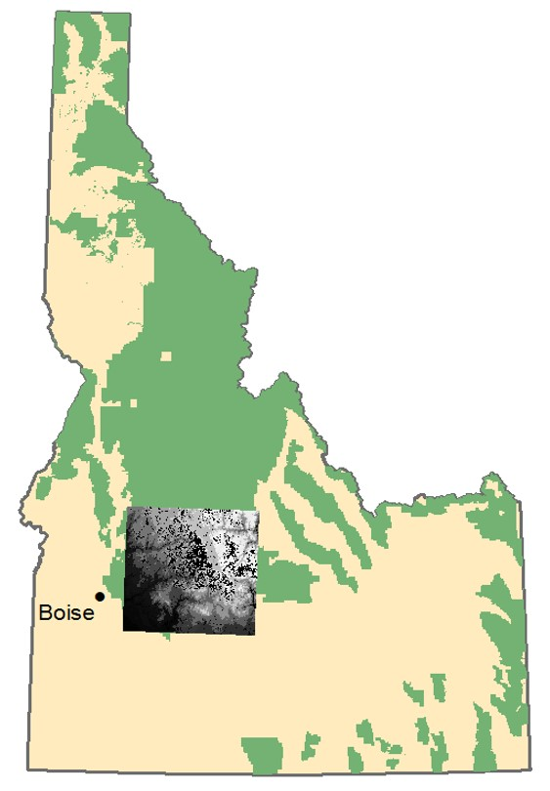*Goals:* Analyze interacting effects of climate change and fire on aspen distribution at a landscape scale.

*Study Extent:* Portion of study extent in the original proposal, as presented in Boise in April 2015 (see Figure 2)

*Extensions:* Biomass Succession, Dynamic Fire and Fuels

*Cell size:* 100 x 100m (1ha)

*Simulation duration*: 90 years

*Narrative:* Increased fire associated with climate change may help aspen regeneration by reducing the pressures of conifer encroachment which have caused aspen declines. However, climate change may also impact the accumulation and longevity of snow banks, which many aspen communities depend on for soil moisture into the growing season. Our simulations will investigate the effects of these competing climatic and ecological pressures to gain insight into the potential fate of this keystone species over the coming century. We will leverage parameters derived from the RCEW scenarios (particularly related to internal LANDIS growth and mortality relationships) to model spatial and temporal trends of species distributions across this larger landscape. Fire will be included in these scenarios, as some fires in the region can reach several hundred thousand acres and the RCEW study extent is not large enough to capture these large events. Several different climate scenarios will be run

Figure : Original Sawtooth study extent. The updated study design will reduce this study extent to exclude areas not pertinent to our questions of interest